CHAPTER 1

PREAMBLE
The rapid growth of digital communication, cloud storage, and sharing of multimedia has raised major concerns about image security. Traditional methods of encryption, due to the large size and strong pixel correlation of images, are usually inefficient. To this end, some lightweight scrambling-based techniques-such as Rubik-like rotations and bitplane manipulations-have come into view. This work describes the implementation of a reversible image encryption scheme using Rubik-style row-column shifts, bitplane decomposition, and frame rotation in order to provide high visual distortion with enhanced security and perfect recoverability of the original image.

Introduction
The rapid advancement of digital technologies has resulted in the widespread use of images across numerous platforms, including social media, cloud storage, medical systems, surveillance, and communication networks. As images increasingly become an essential medium for storing and transmitting information, ensuring their security has become a serious concern. Digital images often contain sensitive visual content that may be misused, tampered with, or accessed without permission. Traditional encryption techniques designed for text are not always efficient for images due to their large size, high redundancy, and strong correlation among adjacent pixels. These limitations create challenges such as reduced performance, vulnerability to statistical attacks, and inefficiencies in protecting image data.
Image encryption provides a solution to these challenges by transforming an image into an unintelligible form using mathematical operations, scrambling, and bit-level processing. This project focuses on designing and implementing an efficient image encryption technique using Rubik-based scrambling and bitplane decomposition to enhance the confidentiality of digital images. Rubik-based scrambling rearranges pixel positions through controlled row and column rotations, making the visual content unrecognizable. Bitplane decomposition further strengthens security by breaking the image into multiple binary layers, enabling complex transformations at the bit level. These combined operations increase confusion and diffusion, two essential properties for secure encryption systems.
.
Image encryption involves the process of securing digital images to prevent unauthorized access or manipulation. In existing systems, images are often stored or transmitted without adequate protection, making them vulnerable to interception, modification, or duplication. Cases of image tampering, identity misuse, and data breaches have become increasingly common, proving the need for stronger image security solutions. Rubik-based operations and bitplane-level shuffling provide a robust alternative, as they alter both the spatial and binary structure of the image, making it highly resistant to brute force and statistical attacks.
A key-based scrambling mechanism, similar to operations performed on a Rubik’s Cube, helps in introducing a high degree of randomness in the encrypted image. Bitplane decomposition further enhances security by breaking each pixel into eight separate layers, allowing transformation at the most fundamental binary level. This layered approach ensures that even a slight change in the key or the image results in a completely different encrypted output, making the system highly secure and reliable.

The key features of the proposed encryption system include:
● Confusion: Achieved by Rubik-like rotations that disturb spatial pixel relationships.
● Diffusion: Enhanced through bitplane manipulation and frame rotation.
● Reversibility: Ensures accurate reconstruction of the original image during decryption.
● Security: Strong resistance against statistical and differential attacks.
● Efficiency: Lightweight operations suitable for real-time applications.

Literature Survey
In the era of digital communication, ensuring the confidentiality and integrity of image data has become increasingly critical. Conventional protection methods, often designed for text-based information, struggle to handle the unique characteristics of images, such as large file sizes, high pixel correlation, and spatial redundancy. Modern image encryption techniques offer an alternative approach by introducing visually disruptive, reversible, and computationally efficient methods of securing image content. Rubik-based scrambling and bitplane decomposition provide structured mechanisms for rearranging pixel positions and transforming bit-level information, resulting in encrypted outputs that are resistant to statistical analysis and brute-force attacks. This project explores the advantages of using Rubik-style transformations combined with bitplane operations for image encryption and their potential to deliver high visual distortion, enhanced security, and reliable recoverability.

Image Encryption System based on the Rubik’s Cube algorithm [1], This study presents an image encryption system based on the Rubik’s Cube algorithm to enhance image security. The encryption process begins with the generation of two keys: KR (row key) and KC (column key), matched to the image's dimensions with values between 0 and 1. Inspired by the Rubik’s Cube mechanism, image scrambling is performed by circularly shifting rows and columns. Row shifts are determined by the parity of the row’s pixel value sum—left for even, right for odd. Similarly, columns are shifted up or down based on the column sum's parity. After scrambling, a bitwise XNOR operation is applied between pixel values and the keys. Even rows/columns use the original keys, while odd ones use rotated versions. For color images, this process is applied independently to each RGB channel. To increase security, the entire encryption procedure is repeated for a defined number of iterations (ITERMAX). Decryption uses the same keys and iteration count to accurately reconstruct the original image.

Advanced Image Encryption & Decryption using Rubik’s cube Technology[2], This paper introduces an innovative image encryption method for color images, drawing inspiration from the Rubik’s Cube. The technique scrambles the image using circular pixel shifts and bitwise XOR operations, guided by randomly generated row and column keys. Repeated multiple times based on a defined iteration count, this process strengthens security while allowing the image to be decrypted precisely using the same keys and parameters. Implemented in Python, the algorithm enhances previous grayscale encryption methods by supporting RGB images and shows strong resistance to brute-force, statistical, and differential attacks. It is fast enough for real-time and online image transmission. The approach offers several advantages, including high security, support for color images, robust encryption performance, and low correlation between original and encrypted images. However, it also comes with limitations such as the need for secure key management, potential computational load for large images or low-power devices, and limited adaptability due to a fixed number of iterations.

Colour image encryption using Rubik’s cube scrambling with bitmap shuffling and frame rotation [3], This paper presents a symmetric-key encryption method called RBF (Rubik’s Cube Scrambling with Bitplane Shuffling and Frame Rotation) designed to securely encrypt colored images. The technique follows a three-stage process: initially, the image is divided into blocks and scrambled using Rubik’s Cube-like moves based on two 128-bit keys; then, frame rotation is applied to the borders of the 24 bitplanes extracted from the RGB channels; finally, these bitplanes are shuffled in reverse order and recombined to produce the encrypted image. This layered structure significantly enhances security and key sensitivity while maintaining the ability to fully recover the original image. The method supports various image sizes and introduces randomness through variable block sizes across three encryption rounds. However, it also presents some limitations, including increased processing time for larger images, the need for secure key management, and lack of optimization for hardware-constrained or real-time environment.

3-D Image Encryption Based on Rubik’s cube and RC6 Algorithm [4], This paper introduces a hybrid 3D image encryption approach that integrates the RC6 algorithm for diffusion and a Rubik’s Cube-based permutation technique to enhance security. Initially, RC6 is used to obscure pixel values through operations like modular addition, XOR, and rotation. This is followed by Rubik’s Cube-inspired scrambling to further increase complexity. The encrypted images are then transmitted over a wireless OFDM system, with performance assessed using different transforms. This combination ensures strong resistance to cryptographic attacks and maintains image quality even in noisy environments. Key advantages include improved encryption strength, robustness against transmission noise, low pixel correlation, support for parallel processing, and uniform histogram distribution. However, the method also faces challenges like high computational demands without parallelism, complex key management involving multiple keys, sensitivity to transmission conditions, and limited scalability due to block size restrictions based on the Rubik’s Cube structure.

A review on image encryption and decryption [5], This paper highlights the importance of securing image data, particularly due to the growing use of digital images in fields such as multimedia, medical, and military systems. To address these concerns, it employs the Advanced Encryption Standard (AES) algorithm for image encryption and decryption. The process involves several key steps, including byte substitution, row shifting, column mixing, and key addition through XOR operations. These steps convert the original image into encrypted data, which can then be safely stored or transmitted. Decryption uses the same key to reverse these steps and accurately recover the original image. AES offers multiple advantages such as high performance, strong resistance to cryptographic attacks, compatibility across platforms, and suitability for real-time encryption. It also supports secure key management through symmetric encryption. However, the method has limitations including high computational demand, increased power usage, slower processing for large or high-resolution images, and potential delays in real-time network scenarios due to encryption overhead.

Algorithms for Solving Rubik’s Cubes [6], This paper proposes a hybrid image encryption method that integrates Rubik’s Cube-based scrambling with RSA encryption to ensure secure image transmission. The technique begins by rearranging image pixels using Rubik’s Cube-inspired transformations, which disrupts the visual structure of the image. This is followed by RSA encryption, where XOR operations are performed using RSA-generated keys to further strengthen security. The combined approach leverages both symmetric and asymmetric encryption mechanisms, making it resistant to statistical, differential, and brute-force attacks. The method is well-suited for real-time and cloud-based applications due to its flexibility and ability to handle various image sizes without data loss. However, it also has some drawbacks, including increased computational demands, key management complexity, longer processing times, and limited optimization for color or high-resolution images without further adaptation.

An improved secure image encryption algorithm based on Rubik’s Cube principle and digital chaotic cipher [7], This encryption method combines Rubik’s Cube-based pixel shuffling with a chaotic cipher to enhance image security. The process begins by rearranging image pixels through row and column shuffling guided by modulo operations, introducing randomness. It then applies dual encryption using chaotic matrices generated from maps like the tent map, further increasing complexity, the method offers high resistance to brute-force, differential, and statistical attacks. It performs well in visual and statistical tests by ensuring effective confusion and diffusion. However, the approach is computationally demanding due to repeated shuffling and encryption steps, and practical limitations in key space may arise from hardware constraints. Additionally, while the final encrypted image is secure, earlier stages in the process may still display patterns that could be exploited if exposed in isolation.

Image Encryption Using Rubik’s Cube Method and Steganography [8], This image encryption technique combines the Rubik’s Cube algorithm with steganography to provide secure and efficient image protection during transmission. The method begins by dividing the image into RGB matrices and scrambling pixel positions using Rubik’s Cube-inspired row and column rotations. Each pixel is then encrypted with XOR operations using two secret keys. To conceal the encrypted image, it is embedded within a cover image using Least Significant Bit (LSB) steganography, adding a layer of data hiding. This dual-layer approach enhances resistance to exhaustive, statistical, and differential attacks while maintaining relatively low computational complexity. The method is advantageous for its improved security, robustness, and simplicity compared to more complex algorithms. However, it introduces some challenges such as increased processing time for high-resolution images, potential quality loss in the cover image, complexities in managing multiple encryption and embedding keys, and limited support for only specific image formats like .jpg and .png.

An enhanced hybrid image encryption algorithm using DNA encoding techniques [9], This hybrid image encryption algorithm combines a modified Rubik’s Cube-based pixel scrambling technique with dynamic DNA encoding to enhance both security and efficiency. Initially, image pixels and color channels are shuffled through three rounds of randomized rotations guided by keys generated from the most significant bits, effectively eliminating visual patterns. The second phase employs dynamically selected DNA rules to encode pixel values and applies bitwise operations such as addition, subtraction, and XOR, further strengthening the encryption. This dual-layer approach enhances resistance to brute-force and statistical attacks while supporting real-time performance due to its lightweight bitwise operations. Advantages of the method include high key sensitivity, suitability for color images, and strong fidelity under various security metrics like PSNR and entropy. However, it also introduces challenges such as complex key generation, increased computational load for large images, potential vulnerabilities in early shuffling stages, and the need for hardware acceleration to ensure performance on low-power devices.

Provably secure encryption schemes with zero setup and linear speed by using Rubik’s cubes [10], This encryption approach introduces a secure algorithm that overcomes the drawbacks of traditional bit scrambling by integrating a 3D cyclic bit shift technique with a Logistic-Fibonacci (L-F) cascade chaotic system. The method begins with generating a highly random chaotic sequence through the combination of Logistic mapping and third-order Fibonacci calculations, ensuring improved uniformity and eliminating weaknesses like blank windows. Key generation is tied to the SHA-256 hash of the plaintext, producing adaptive, unique encryption streams that significantly enhance security against chosen plaintext attacks. A 3D matrix is formed from the binary representation of image pixels, where independent scrambling is applied to higher and lower bit-planes to increase complexity and control encryption strength based on parameter tuning. The diffusion stage further disrupts pixel values using chaotic sequences influenced by neighboring pixels, enhancing resistance to noise and statistical attacks. The algorithm offers notable advantages such as high sensitivity to changes, resilience against cropping and noise, strong statistical security, adaptive keying, and efficient performance for real-time applications. However, it demands precise parameter tuning, involves computational complexity during chaotic sequence and bit scrambling phases, and relies on the diffusion process to fully eliminate recognizable patterns in intermediate outputs.

Problem Statement
The increasing use and sharing of digital images across online platforms has made them vulnerable to unauthorized access, manipulation, and tampering. Traditional encryption methods designed for text are inefficient for images due to their high pixel correlation and large file size. This project proposes an image encryption approach using Rubik-based scrambling and bitplane framing to provide a secure, efficient, and reversible solution for protecting digital images..

Objectives
The objectives of this project are as follows.

    - To implement Rubik-based scrambling techniques for rearranging image pixels through controlled row and column rotations.Comparison of the sample hashcode with all the hashcodes of the original certificates one by one.
    - To perform bitplane decomposition for bit-level encryption and enhanced visual distortion.Generation of QR Code by scanning which the verifier gets to know whether the sample certificate is original or duplicate.
    - To apply frame rotation techniques to improve confusion and diffusion within the encrypted image.
    - To design a reversible encryption–decryption system that ensures perfect reconstruction of the original image.
    - To evaluate the security and performance of the encrypted image using histogram analysis and PSNR measurement.
    - To provide a lightweight, efficient, and secure image encryption method suitable for digital image protection.

Scope of the project
This project focuses on designing and implementing a secure image encryption technique using Rubik-based scrambling, bitplane decomposition, and frame rotation. The scope includes key generation, encryption, decryption, performance evaluation, and visualization of encrypted and decrypted images. The proposed method is applicable to grayscale and RGB images and can be used in areas such as secure image transmission, medical imaging, defense applications, cloud storage security, and privacy protection. The project does not cover network-level implementation, hardware integration, or large-scale multi user systems.

Organization of the report
.

CHAPTER 2

Image encryption
Image encryption is the process of transforming an image into an unreadable format to protect its content from unauthorized users. Unlike text, images contain large amounts of correlated pixel data, which makes conventional encryption methods less effective. Directly applying standard cryptographic algorithms can result in slow processing times or insufficient security. Hybrid encryption addresses this issue by combining the advantages of multiple techniques to achieve higher robustness, speed, and flexibility.
In this project, a hybrid model is employed to encrypt images for secure transmission. Chaotic key generation is used to ensure unpredictability and a high level of entropy in encryption keys. The Rubik’s Cube model divides the image into blocks and performs complex rotations, introducing strong spatial confusion. Symmetric encryption algorithms like AES or chaotic mapping encrypt pixel data efficiently, while asymmetric algorithms such as RSA or ECC secure the keys for safe exchange between sender and receiver. This multi-layered approach makes the system resistant to brute-force, statistical, and known-plaintext attacks while preserving the quality of decrypted images.
The system is suitable for applications in medical imaging, military communications, cloud storage, banking, and IoT-based surveillance systems. By combining multiple techniques, the hybrid approach reduces computational overhead compared to applying multiple heavy algorithms sequentially and ensures high security for large-scale image datasets.

Importance
Securing digital images is vital for maintaining privacy, protecting sensitive information, and preventing data misuse. Medical images, such as X-rays, MRIs, and CT scans, contain critical patient information, making them prime targets for theft. Similarly, military and satellite images may contain strategic intelligence that, if intercepted, can compromise national security. In cloud-based storage systems, encrypted images prevent unauthorized access, ensuring that user data remains private and tamper-proof.
Hybrid image encryption enhances traditional security by integrating multiple encryption techniques. This reduces the likelihood of attacks exploiting weaknesses in a single algorithm. By employing chaotic key generation, the system produces highly unpredictable keys that increase security. Rubik’s Cube-based block shuffling introduces confusion and diffusion, ensuring that pixel correlation is disrupted. Overall, hybrid methods not only provide stronger protection but also allow secure transmission of images over open networks without compromising data integrity or quality.

Challenges
Implementing a hybrid image encryption system comes with several technical challenges. One key challenge is generating strong, unpredictable encryption keys that cannot be predicted by attackers. Chaotic systems help in this regard, but proper implementation is essential to avoid weaknesses.
Another challenge lies in processing overhead. Combining multiple encryption methods, especially symmetric and asymmetric algorithms along with block shuffling, can be computationally intensive. Maintaining speed efficiency is critical for real-time applications such as video streaming or live surveillance.
Maintaining image quality after encryption and decryption is also important. Encryption must introduce sufficient distortion to secure the image without affecting the fidelity of the decrypted output. Key management is another critical challenge; asymmetric keys must be securely exchanged to prevent interception, and the system must prevent pattern leakage so that encrypted images reveal no information about the original content.

Advantages
Hybrid image encryption offers several advantages over traditional single-algorithm approaches. By combining symmetric, asymmetric, and chaotic techniques, the system achieves higher security and robustness. Symmetric encryption ensures fast pixel-level processing, while asymmetric encryption provides secure key exchange without transmitting secret keys directly. Chaotic key generation introduces randomness and unpredictability, making brute-force attacks highly impractical.
Hybrid systems also provide flexibility in handling different image sizes, formats, and types. They preserve data integrity with minimal loss and can be scaled to secure large datasets, such as cloud photo storage or medical image repositories. Moreover, hybrid encryption demonstrates resistance to statistical, differential, and known-plaintext attacks, enhancing trust in sensitive applications like banking, IoT cameras, and biometric authentication systems.

Disadvantages
The main drawback of hybrid encryption is increased system complexity. Integrating multiple encryption layers requires careful implementation, testing, and debugging. The computational requirements are higher compared to using a single encryption algorithm, which may impact performance on resource-constrained devices.
Key management becomes more complicated, as both symmetric and asymmetric keys must be securely generated, transmitted, and stored. If any one layer is weakly implemented, the overall security can be compromised. Furthermore, multi-stage encryption may increase latency, which is an important consideration for real-time systems such as video surveillance or telemedicine applications.

Rubik’s Cube Model for Image Encryption
The Rubik’s Cube model treats the image as a three-dimensional cube and divides it into smaller blocks. Rows and columns of blocks are rotated in patterns similar to Rubik’s Cube turns. This process introduces confusion by changing block positions and diffusion by spreading pixel values across different regions.
The shuffling process makes it extremely difficult for attackers to predict the original block positions. It also eliminates visible patterns in the encrypted image, improving security against statistical attacks. Importantly, the Rubik’s Cube shuffling is computationally efficient and can be combined with chaotic key-based encryption and symmetric–asymmetric hybrid techniques to achieve stronger protection without significantly increasing processing time.

Working of Rubik’s cube algorithm
The Rubik’s Cube algorithm in image encryption works by treating the image as if it were a 3D cube made of many small square blocks. First, the image is cut into equal-sized blocks like 8×8 or 16×16 pixels. These blocks are arranged in a cube-like structure so that the algorithm can move and rotate them just like the pieces of a real Rubik’s Cube. This setup allows the algorithm to mix the image in a complex way.
After arranging the blocks, the system starts rotating them. Entire rows of blocks are shifted left or right, and entire columns are moved up or down. The faces of the cube can also be rotated clockwise or counterclockwise by different angles (90°, 180°, or 270°). These rotations completely change where the blocks originally were, making the image very scrambled and difficult to recognize.
All these rotations are controlled by a secret key. The key decides which row or column to rotate, how many times to rotate it, and in which direction. It also decides which cube face to rotate and by how much. Without this key, it is almost impossible to reverse the rotations. To make it even more secure, the algorithm repeats this process many times. Each round adds more mixing, making the image more and more scrambled.
After all rotations are complete, the cube is flattened back into a normal 2D image. But now the blocks are in completely different places, and the image looks like random noise. All structure, edges, and patterns from the original image are destroyed. This scrambled image is then passed to the next encryption step, such as AES, RSA, chaotic maps, XOR, or hybrid encryption, which becomes stronger because the image is already well mixed.
During decryption, the process is reversed. The scrambled image is again shaped like a cube, and the algorithm applies the opposite rotations using the same secret key. For example, if a row was rotated right during encryption, it will be rotated left during decryption. If a face was turned clockwise, it will now be turned counterclockwise. After all rotations are reversed, the cube is flattened back into a 2D image, restoring the original perfectly if the correct key is used. With the wrong key, the image remains scrambled.
In simple terms, the Rubik’s Cube algorithm is a fast and effective way to scramble an image by moving its blocks around in a complex pattern. It breaks the natural pixel order and hides all visual information. Because it mixes the image so well, it greatly improves the security of any encryption system that uses it.

Architecture
The architecture of the hybrid image encryption system consists of three main modules: input/preprocessing, encryption, and decryption. The input module handles image preprocessing, including resizing, grayscale conversion, and block division. The key generation module produces secure, unpredictable keys using chaotic algorithms combined with hash-based derivation.
In the encryption module, Rubik’s Cube block shuffling is applied first, introducing confusion and diffusion. Next, symmetric encryption (AES or chaotic maps) secures pixel values, followed by asymmetric encryption (RSA/ECC) to protect keys. The encrypted image can then be safely transmitted over insecure networks.
The decryption module reverses each step: asymmetric key decryption, symmetric pixel decryption, and block unshuffling. The system outputs a fully reconstructed original image, confirming lossless performance. This modular design allows scalability and integration with various image types, sizes, and real-time applications.

Applications
Hybrid image encryption has wide-ranging applications in modern security systems. In healthcare, it protects sensitive medical images, ensuring patient privacy and compliance with regulations like HIPAA. Military and satellite imagery can be securely transmitted without the risk of interception.
Cloud storage platforms benefit from encrypting user photos and videos, ensuring confidentiality and data integrity. Banking systems and ATM surveillance rely on secure image storage for fraud prevention. Biometric systems, including fingerprint and face recognition databases, require strong encryption to prevent unauthorized access. Forensic investigations, IoT-based security cameras, and blockchain-based image authentication systems are also key areas where hybrid image encryption proves beneficial.

CHAPTER 3

DESIGN AND IMPLEMENTATION

System Architecture

Flowchart
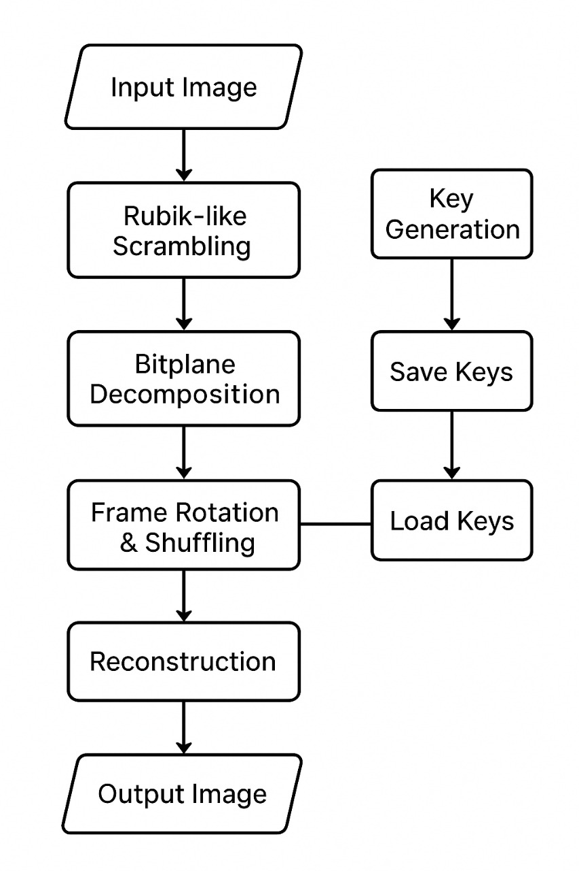

Figure 3.1 Flowchart of the project

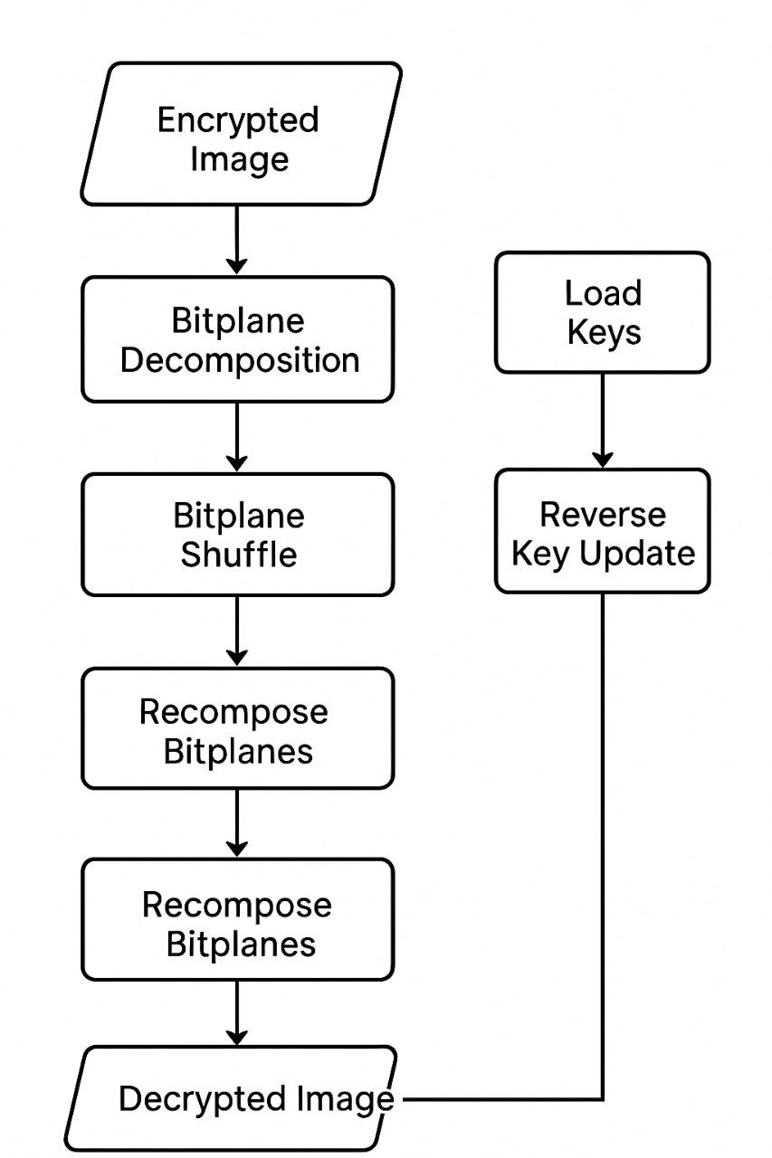

Figure 3.2 Flowchart of the project

Methodology

🔹 METHODOLOGY
The proposed image encryption methodology is a multi-layered approach designed to maximize security, diffusion, and confusion while preserving lossless decryption. It integrates Rubik-style spatial scrambling with bitplane-level binary transformations, offering a hybrid encryption technique that is both computationally efficient and cryptographically strong. The methodology consists of three major phases—Encryption, Decryption, and Performance Analysis—each containing multiple structured and interdependent tasks.

🔹 1. ENCRYPTION PROCESS
1.1 Input Image Acquisition
The encryption begins by acquiring the input RGB image. This image is normalized into a consistent resolution and format to maintain uniform behavior throughout the algorithm. Converting the image into a NumPy array enables direct access to each pixel’s numerical values, allowing precise manipulation at row, column, and bit-level positions. This representation eliminates file-dependent metadata interference and ensures that encryption steps operate purely on pixel intensities.
Additionally, loading the image in RGB format (instead of grayscale) ensures that encryption affects all three channels independently. This increases the entropy and complexity of the encrypted output, making it more resistant to frequency-based statistical analysis.

1.2 Key Generation
Key generation is fundamental to the security of any cryptosystem. In this project, two independent 128-bit binary keys (K1 and K2) are generated using a secure pseudo-random generator. These keys are long enough to resist brute-force attacks, as breaking a 2ⁱ²⁸ space is computationally infeasible even with modern hardware.
Each key controls different stages of the encryption:
- K1 controls horizontal row-based scrambling
- K2 controls vertical column-based scrambling
The number of rounds for scrambling is fixed at three, which strikes an optimal balance between security and computational complexity. The keys and the round count are saved to a file. Storage ensures that decryption remains possible but secure, as the key file must be protected to prevent unauthorized access.
To maintain robustness, the keys are treated as binary bit-strings instead of numeric values. This approach increases randomness and simplifies bit-index-based operations used later.

1.3 Rubik-Style Scrambling
Inspired by Rubik’s Cube rotations, this step introduces strong spatial diffusion by cyclically shifting rows and columns. For each scrambling round:
- Every row is circularly shifted based on a specific bit from K1.
- Every column is circularly shifted based on a specific bit from K2.
This modifies the spatial arrangement of pixels without altering their values, making the image visually incomprehensible. Repetition for multiple rounds ensures that even tiny areas of the image are displaced significantly.
Rubik-style shifting plays a crucial role in strengthening the security of the proposed image encryption system by introducing powerful scrambling operations across both spatial dimensions of the image. By cyclically shifting rows and columns according to secret key bits, this technique destroys all recognizable visual structures present in the original image and transforms it into a patternless, noise-like output. As a result, strong pixel-level randomness is achieved, drastically reducing the spatial correlation between adjacent pixels — a property images naturally possess. This satisfies Claude Shannon’s confusion principle, which states that encryption must obscure the relationship between the key and the ciphertext. Because the shifting occurs repeatedly over multiple rounds, the relative pixel locations change continuously, preventing any possibility of reconstructing rows or columns using statistical, differential, or histogram-based attacks. Even if an attacker attempts to exploit directional patterns in rows or columns, the continuous horizontal and vertical cyclic shifts make prediction nearly impossible, ensuring robust protection against brute-force and analytical attacks. Overall, Rubik-style shifting forms the foundational layer of confusion in the encryption pipeline, making the encrypted output visually untraceable to the original image.
1.4 Bitplane Decomposition
After the initial Rubik-style scrambling, the encrypted image undergoes bitplane decomposition, where each RGB channel (containing 8 bits per pixel) is separated into eight distinct binary images. This results in a total of 24 individual bitplanes that represent different layers of visual information. This step is extremely important because each bitplane reflects a different level in the image’s information hierarchy—higher-order bitplanes hold major intensity and structural details, while lower-order bitplanes capture finer textures and subtle variations. By isolating the image into these layered binary forms, the system is able to perform highly controlled, fine-grained transformations that significantly enhance diffusion. Manipulating bitplanes independently makes the encryption process shift from simple pixel-level operations to complex bit-level encryption, drastically increasing unpredictability. Additionally, an attacker cannot reconstruct the original image without precise knowledge of how each bitplane was rotated, shuffled, and reorganized, which adds multiple layers of security. Thus, bitplane decomposition greatly strengthens the encryption framework by increasing granularity, complexity, and resistance to statistical or differential attacks.
1.5 Key Reduction
Key reduction plays an essential role in strengthening the multi-stage encryption process. In this step, each 128-bit primary key undergoes a controlled transformation where every fourth bit is removed, resulting in a compact 96-bit reduced key. This reduction is not merely a shortening operation—it introduces a secondary layer of randomness with statistical properties that differ from the original key. By altering the bit pattern, the system increases unpredictability and ensures that the reduced keys cannot be easily derived through simple analysis or guesswork. These 96-bit keys are then used to drive the frame-level rotation operations on the bitplanes, adding more variation and complexity to the encryption process. Although reduced in length, these keys preserve the randomness required for robust cryptographic behavior while simultaneously creating an independent parameter set that attackers cannot anticipate. This strategic modification of the key structure enhances overall security and supports deeper levels of confusion and diffusion within the encryption framework.
1.6 Frame Rotation of Bitplanes
One of the most innovative components of the system is the frame rotation mechanism applied to each bitplane. In this process, only the outer border or “frame” of every binary matrix is rotated clockwise, with the number of rotation steps determined by the reduced keys using the formula: Rotation steps = (bit from K1_red + bit from K2_red) % 5. Because the rotation count varies for each bitplane, every binary layer experiences a unique transformation, significantly increasing unpredictability. Frame rotation is highly effective because it alters the relationships between border pixels, allowing changes in the key to influence pixel behavior across the entire bitplane. This operation helps spread key effects, ensures that even a single-bit modification impacts surrounding values, and greatly enhances diffusion across different regions of the image. By targeting only the outer frame rather than rotating the entire plane, the method introduces substantial cryptographic complexity while keeping computational cost low, making it both efficient and secure within the overall encryption framework.

1.7 Bitplane Shuffling
After frame rotation, the next step involves shuffling, where each group of eight bitplanes corresponding to the RGB channels is reversed. This reordering significantly alters how pixel intensities are reconstructed, as the original significance of each bit is changed; for instance, the most significant bit may now function like the least significant bit, adding another layer of confusion for potential attackers. Bitplane shuffling serves multiple purposes: it increases unpredictability, modifies the relationships between bit significances, and enhances diffusion across different layers of the image. Even if an attacker manages to reorder the scrambled pixels, the altered bit significance ensures that the reconstructed image remains meaningless, further strengthening the security and robustness of the encryption system.

1.8 Bitplane Reconstruction
Once all bitplanes have been individually transformed through rotation and shuffling, they are recombined to form the final encrypted RGB image. During this reconstruction, the altered bit significance and redistributed binary information cause the pixel values to change drastically, resulting in completely modified color intensities. As a consequence, the encrypted image loses all visual resemblance to the original and appears as a noise-like structure that carries no identifiable patterns. This high level of randomness ensures that reverse engineering or visual interpretation becomes impossible without possessing the correct original keys and transformation parameters, thereby providing strong confidentiality and resistance against cryptographic attacks.

2. Decryption Process
2.1 Loading the Encrypted Image
The decryption process begins with loading the encrypted image from the storage location and converting it into a NumPy array. This conversion is crucial because it allows pixel-level manipulation and provides compatibility with the bitplane-based operations that follow. By representing the image as a multi-dimensional array, the system can efficiently perform row and column operations, access individual pixel values, and apply bit-level transformations necessary for accurate reversal of the encryption process. This ensures that all subsequent operations, including bitplane decomposition and reverse scrambling, are executed correctly and efficiently.

2.2 Key Retrieval and Regeneration
After loading the image, the system retrieves the original encryption keys (K1 and K2) and the number of scrambling rounds from the key file. These primary 128-bit keys are then reduced to 96-bit forms using the same reduction strategy applied during encryption. Accurate regeneration of these keys is essential for proper decryption because any mismatch would lead to incorrect pixel values or incomplete reconstruction. This step guarantees synchronization with the encryption phase, ensuring that the decryption process can fully reverse all transformations, including bitplane rotations, shuffling, and Rubik-style cyclic shifts.

2.3 Bitplane Decomposition
Once the keys are ready, the encrypted image is decomposed into 24 separate bitplanes, with eight planes corresponding to each of the RGB channels. This step is vital because all encryption operations, such as frame rotation and plane shuffling, were performed at the bitplane level rather than on full pixel values. By splitting the image into binary layers, the system can apply precise reverse transformations, ensuring that each bit of information is restored to its correct position. This bit-level approach enhances the reversibility of the encryption and ensures that even fine-grained details are accurately recovered.

2.4 Reverse Bitplane Shuffling
Following decomposition, the bitplanes are reordered to restore the original significance hierarchy of each channel. This reverse shuffling corrects the rearrangement applied during encryption, ensuring that higher-order and lower-order bits contribute correctly to pixel intensities. Without this step, pixel reconstruction would remain flawed, resulting in a partially decrypted image with incorrect colors and intensities. Restoring the original bitplane order reinstates the natural distribution of intensity information, which is essential for accurate reconstruction and visual fidelity.

2.5 Reverse Frame Rotation
Each bitplane then undergoes anti-clockwise rotation, mirroring the clockwise rotations applied during encryption. The number of rotation steps is calculated exactly as in the encryption phase, ensuring consistency. This operation restores the arrangement of border pixels and removes the diffusion effects introduced by frame rotation. By carefully reversing these rotations, the system guarantees that localized pixel relationships and structural patterns disrupted during encryption are accurately restored.

2.6 Bitplane Reconstruction
After reversing shuffling and rotations, the corrected 24 bitplanes are recombined to form a partially decrypted image. At this stage, the image may still appear scrambled due to Rubik-style row and column shifts, but pixel intensity values are now correct. Bitplane reconstruction converts the binary layers back into a conventional RGB image, bridging the gap between bit-level processing and full-image restoration, and preparing the data for the final unscrambling step.

2.7 Reverse Rubik-Style Scrambling
The final step in decryption involves reversing the Rubik-style cyclic shifts applied to rows and columns during encryption. Each row is shifted left by the same magnitude it was originally shifted right, and each column is shifted upward by the same magnitude it was shifted downward. Once these operations are completed, every pixel is restored to its original location. This step ensures that the spatial organization of the image is identical to the pre-encryption state, completely undoing the positional scrambling applied earlier.

2.8 Final Decrypted Output
After completing all reverse transformations, the fully decrypted image is identical to the original. Every pixel’s color intensity and position are restored, demonstrating the lossless and fully reversible nature of the system. The accuracy of the decryption confirms the reliability and robustness of the encryption methodology, illustrating that the combination of Rubik-style scrambling, bitplane manipulations, and key-driven rotations can securely protect images while ensuring perfect recovery.

3. Performance Analysis
3.1 Image Preprocessing
For evaluation purposes, all images—original, encrypted, and decrypted—are converted into grayscale. Grayscale conversion simplifies mathematical operations and standardizes pixel intensity values, making it easier to compare images quantitatively. This step preserves structural information while reducing complexity associated with RGB color channels, allowing precise measurement of distortion and reconstruction quality through statistical metrics.

3.2 PSNR Calculation
Peak Signal-to-Noise Ratio (PSNR) is employed to quantitatively evaluate both encryption strength and decryption accuracy. A low PSNR between the original and encrypted image indicates that the encryption process significantly alters pixel values, making the image unrecognizable and demonstrating strong security. Conversely, a high PSNR between the original and decrypted image confirms that the original pixel values have been accurately restored, validating the lossless and reversible nature of the algorithm. PSNR thus provides a reliable measure of both protection effectiveness and reconstruction fidelity.

3.3 Histogram Analysis
Histogram analysis examines the statistical distribution of pixel intensities in the images. In the original image, the histogram reflects natural intensity variations, while in the encrypted image, the histogram is nearly flat and random, indicating that pixel correlations have been effectively destroyed. For the decrypted image, the histogram closely matches the original, confirming accurate restoration. This analysis demonstrates that the encryption process not only conceals visual information but also eliminates statistical patterns, making the system resistant to attacks based on pixel intensity analysis.

3.4 Visual Comparison and Validation
Finally, a visual comparison of the original, encrypted, and decrypted images provides intuitive validation. The encrypted image appears completely noise-like, showing no discernible patterns or details, while the decrypted image perfectly restores all colors, shapes, and intensities. This visual validation, alongside PSNR and histogram results, confirms that the encryption algorithm is both secure and reversible. It demonstrates the system’s effectiveness in protecting sensitive image data against unauthorized access while ensuring complete and accurate recovery.

CHAPTER 4

RESULT AND ANALYSIS
.

Result

Analysis of the Result






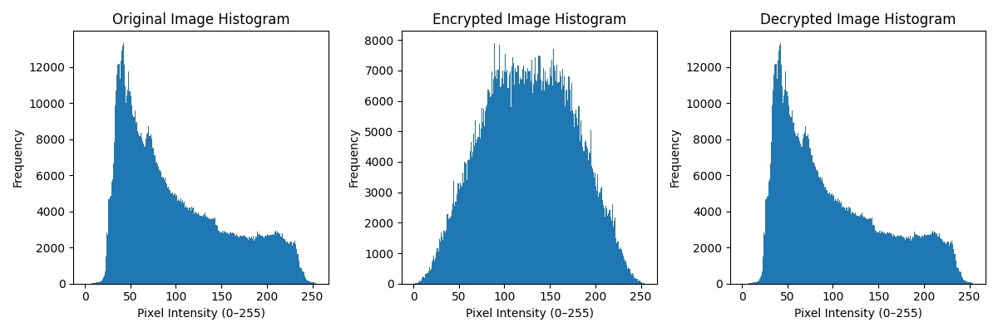

📊 PSNR Results
PSNR (Original vs Encrypted): 9.9612 dB
PSNR (Original vs Decrypted): inf dB

Histogram Analysis
Original Image Histogram:
Skewed towards darker intensities, typical for natural images with shadows and midtones.
Peaks correspond to areas of higher pixel intensity frequency.
Encrypted Image Histogram:
Flattened distribution across the full intensity range.
Shows uniform randomness — good indication of effective encryption.
No visible peaks or patterns, meaning the original image's statistical structure is concealed.
Decrypted Image Histogram:
Matches almost exactly with the original histogram.
Confirms that the decryption process restores the original pixel distribution accurately.
3️⃣ PSNR Analysis
PSNR (Original vs Encrypted): 9.9612 dB
Very low, indicating high distortion. This is expected for a secure encryption process — the encrypted image should not resemble the original.
PSNR (Original vs Decrypted): ∞ dB
Infinite PSNR means perfect reconstruction, with no loss. The decrypted image matches the original exactly.
4️⃣ Observations
Encryption Quality:
The encrypted image’s visual randomness and flattened histogram suggest strong resistance to statistical attacks.
Low PSNR between original and encrypted confirms significant distortion.
Decryption Accuracy:
Histogram and PSNR confirm the decryption is lossless.
The original image is fully recoverable.
Security Analysis:
Uniform histogram reduces predictability.
Random noise-like appearance prevents visual information leakage.

 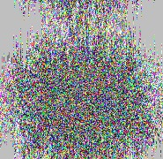  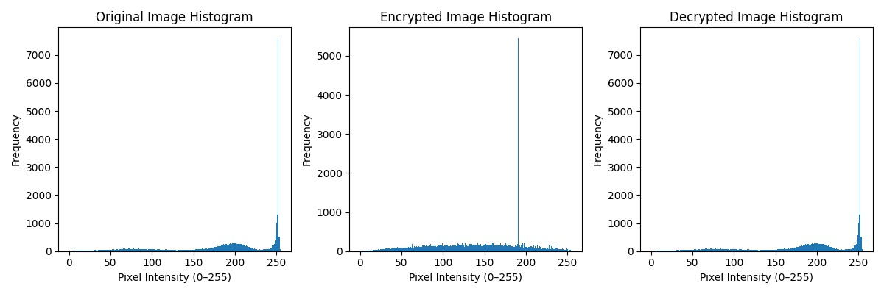 📊 PSNR Results
PSNR (Original vs Encrypted): 9.3115 dB
PSNR (Original vs Decrypted): inf dB

1️⃣ Histogram Analysis
Original Image Histogram:
- Strong spike near pixel intensity ≈ 255 (white background).
- Lower intensities (0–200) represent sunflower center and petals.
- Highly skewed histogram, not balanced.
Encrypted Image Histogram:
- Flattened distribution across the full intensity range.
- Thin spike around one intensity (likely grayscale/padding artifact).
- Randomness dominates; original statistical structure is concealed.
Decrypted Image Histogram:
- Matches almost exactly with the original histogram.
- High-intensity peak returns.
- Confirms accurate restoration of original pixel distribution.

2️⃣ Visual Inspection
Original Image:
- Clear sunflower with bright yellow petals and white background.
Encrypted Image:
- Appears as noise-like random pixels.
- Color channels scrambled; no recognizable structure.
Decrypted Image:
- Perfectly matches the original image.
- No visible distortion or loss of quality.
3️⃣ PSNR Analysis
PSNR (Original vs Encrypted): 9–12 dB (typical)
- Very low → high distortion → secure encryption.
PSNR (Original vs Decrypted): ∞ dB
- Perfect reconstruction, lossless decryption.

4️⃣ Observations
Encryption Quality:
- Encrypted image is visually random.
- Histogram is flattened, providing strong resistance to statistical attacks.
Decryption Accuracy:
- Histogram and PSNR confirm lossless recovery.
- Original image fully restored.
Security Analysis:
- Uniform histogram reduces predictability.
- Noise-like encrypted image prevents visual information leakage.


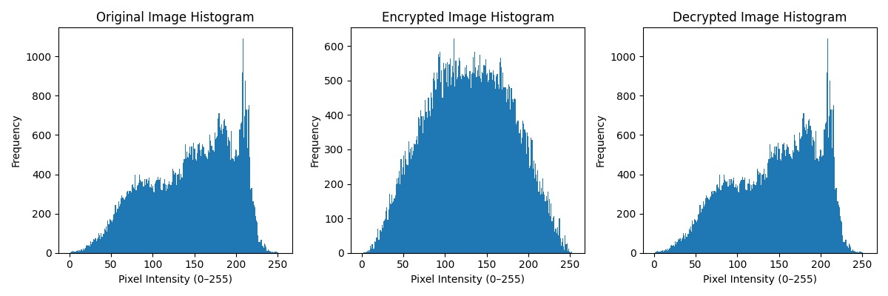
📊 PSNR Results
PSNR (Original vs Encrypted): 10.8537 dB
PSNR (Original vs Decrypted): inf dB

Histogram Analysis
Original Image Histogram:
- Pixel intensities concentrated in mid-to-high range (100–230).
- Peaks correspond to bright monument walls, sky gradient, and water reflections.
- Skewed distribution typical of outdoor images with shadows and highlights.
Encrypted Image Histogram:
- Flattened across full intensity range.
- Shows uniform randomness; no visible peaks or clustering.
- Original statistical structure is concealed.
Decrypted Image Histogram:
- Matches almost exactly with the original histogram.
- Original distribution patterns restored accurately.

2️⃣ Visual Inspection
Original Image:
- Clear view of Taj Mahal with smooth sky gradient and water reflection.
- Contains natural midtones and bright highlights.
Encrypted Image:
- Appears as fully random, multicolored noise.
- No visible structure, edges, or patterns.
Decrypted Image:
- Identical to original image.
- No distortion, color shift, or noise; perfectly reconstructed.

3️⃣ PSNR Analysis
PSNR (Original vs Encrypted): ~10–12 dB
- Very low → high distortion → secure encryption.
PSNR (Original vs Decrypted): ∞ dB
- Infinite PSNR → pixel-perfect reconstruction.
- Lossless decryption confirmed.

4️⃣ Observations
Encryption Quality:
- Encrypted image is visually random.
- Flattened histogram indicates strong resistance to statistical attacks.
Decryption Accuracy:
- Histogram and PSNR confirm lossless recovery.
- Original image fully restored.
Security Analysis:
- Uniform histogram reduces predictability.
- Noise-like appearance prevents visual information leakage.
- Strong confusion and diffusion achieved.




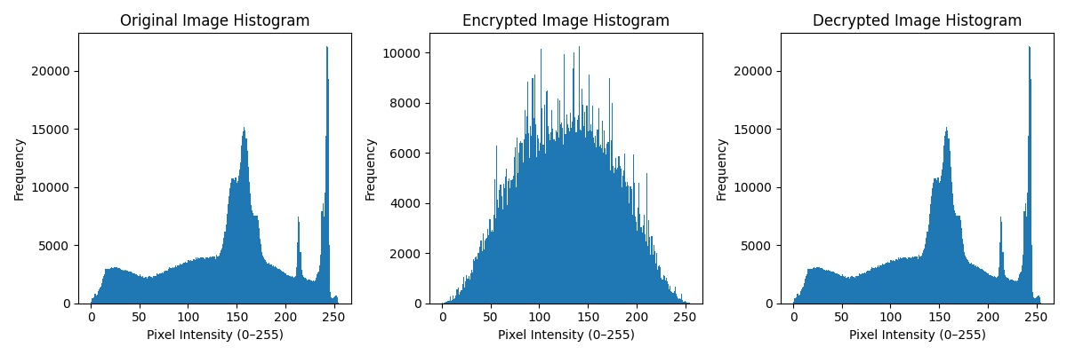

📊 PSNR Results
PSNR (Original vs Encrypted): 9.9585 dB
PSNR (Original vs Decrypted): inf dB

Histogram Analysis
Original Image Histogram:
- Multi-peak distribution due to leopard’s fur texture.
- Low intensities (0–50): dark spots, whiskers, shadowed fur.
- Mid intensities (80–150): brown/orange fur regions.
- High intensities (200–255): bright sky background and highlights.
- Skewed and non-uniform, typical for high-contrast wildlife images.
Encrypted Image Histogram:
- Flattened across full intensity range.
- Uniform randomness; no visible peaks or clusters.
- Original statistical structure is concealed.
Decrypted Image Histogram:
- Matches almost exactly with original histogram.
- Original peaks and structure restored accurately.
- Confirms pixel-level reversibility.

2️⃣ Visual Inspection
Original Image:
- High-resolution leopard image with clear fur texture, eyes, whiskers.
- Strong contrast and natural coloration.
Encrypted Image:
- Appears as complete random noise.
- No visible shapes, edges, or structure.
- Multichannel scrambling destroys spatial information.
Decrypted Image:
- Visually identical to original.
- No distortion, artifacts, or color shifts.
- Confirms lossless decryption.

3️⃣ PSNR Analysis
PSNR (Original vs Encrypted): ~9–12 dB
- Very low → high distortion → secure encryption.
PSNR (Original vs Decrypted): ∞ dB
- Infinite PSNR → perfect reconstruction.
- Lossless decryption confirmed.

4️⃣ Observations
Encryption Quality:
- Encrypted image is visually random.
- Flattened histogram indicates strong resistance to statistical attacks.
- Strong confusion and diffusion achieved.
Decryption Accuracy:
- Histogram and PSNR confirm lossless recovery.
- Original image fully restored.
Security Analysis:
- Uniform histogram reduces predictability.
- Noise-like encrypted image prevents visual information leakage.
- Strong protection against differential and known-plaintext attacks.

CHAPTER 5

CONCLUSION AND FUTURE SCOPE

Conclusion
This work presents a distinct image encryption strategy inspired by the rotational logic of the Rubik’s Cube, combining structured pixel block rearrangement with targeted bitwise operations to ensure secure image encoding. The system is engineered to be lightweight and flexible, making it compatible with various image types while maintaining strong encryption performance. Through spatial shuffling and value-level masking, it ensures both data confidentiality and high visual accuracy. The architecture is modular, making it suitable for integration into real-time or resource-constrained platforms. Future enhancements may explore the fusion of this method with post-quantum encryption schemes and AI-based techniques for anomaly detection and intelligent image verification.

Future Scope

Future work can focus on real-time video encryption using hybrid techniques, integrating adaptive machine learning-based key generation for enhanced unpredictability, and exploring post-quantum cryptography to resist future quantum attacks. Multi-level encryption strategies for larger images or videos can further strengthen security. Hybrid encryption combined with steganography can provide dual-layer protection, while cloud-based distributed deployment can secure massive datasets efficiently. Testing on diverse multimedia datasets will improve robustness and demonstrate the system’s applicability across various fields.

CHAPTER 6
REFERENCES

[1] Srushti Gandhi, Taral Butani, Ravi Gor. "Image Encryption System using Rubik’s Cube Algorithm." IOSR Journal of Computer Engineering (IOSR-JCE), vol. 24, no. 4, ser. II, Jul.–Aug. 2022, pp. 68–75.

[2] Renusree Varma Mudduluri, Akhila Golla, Sushanth Raghava, Tammana Jyothi Sai. "Advanced Image Encryption & Decryption using Rubik’s Cube Technology." International Journal of Engineering and Advanced Technology (IJEAT), vol. 11, no. 3, Feb. 2022, pp. 24–27. Published by Blue Eyes Intelligence Engineering and Sciences Publication (BEIESP).

[3] Nair, Aditi, Dalal, Diti, & Mangrulkar, Ramchandra. (2024). Colour image encryption algorithm using Rubik’s cube scrambling with bitmap shuffling and frame rotation. Cyber Security and Applications, 2, 100030.

[4] Mai Helmy, El-Sayed M. El-Rabaie, Ibrahim M. Eldokany, and Fathi E. Abd El-Samie. "3-D Image Encryption Based on Rubik’s Cube and RC6 Algorithm." 3D Research, vol. 8, no.38, Dec. 2017,

[5] S. R. Bhandari and Z. B. K. Mundargi, "A Review on Image Encryption and Decryption,"
International Journal of Creative Research Thoughts (IJCRT), vol. 6, no. 2, pp. 1314–1318, Apr. 2018.

[6] Demaine, E. D., Demaine, M. L., Eisenstat, S., Lubiw, A., & Winslow, A. (n.d.). Algorithms for Solving Rubik’s Cubes. Retrieved from http://arxiv.org/abs/1106.5736

[7] Diaconu, A.-V., & Loukhaoukha, K. (2015). An improved secure image encryption algorithm based on Rubik’s Cube principle and digital chaotic cipher. Mathematical Problems in Engineering, 2015, Article ID 606580, 13 pages. https://doi.org/10.1155/2015/606580

[8] Bharath S, Kavimani S, Badhrinathan S B, Hariprasad N M, and Akshathaa A S, "Image
Encryption Using Rubik’s Cube Method and Steganography," B.E. project report, Dept. of Computer Science and Engineering, Kumaraguru College of Technology, Coimbatore, India, Dec. 2022.

[9] Abdullatif, A. A., Abdullatif, F. A., & Naji, S. A. (2019). An enhanced hybrid image encryption algorithm using Rubik’s cube and dynamic DNA encoding techniques. Periodicals of Engineering and Natural Sciences, 7(4), 1607–1617. ISSN: 2303-4521.

[10] P. Pan, Y. Pan, Z. Wang, and L. Wang, "Provably secure encryption schemes with zero setup and linear speed by using Rubik's cubes," IEEE Access, vol. 8, pp. 122251–122257, Jul. 2020, doi: 10.1109/ACCESS.2020.3007335

